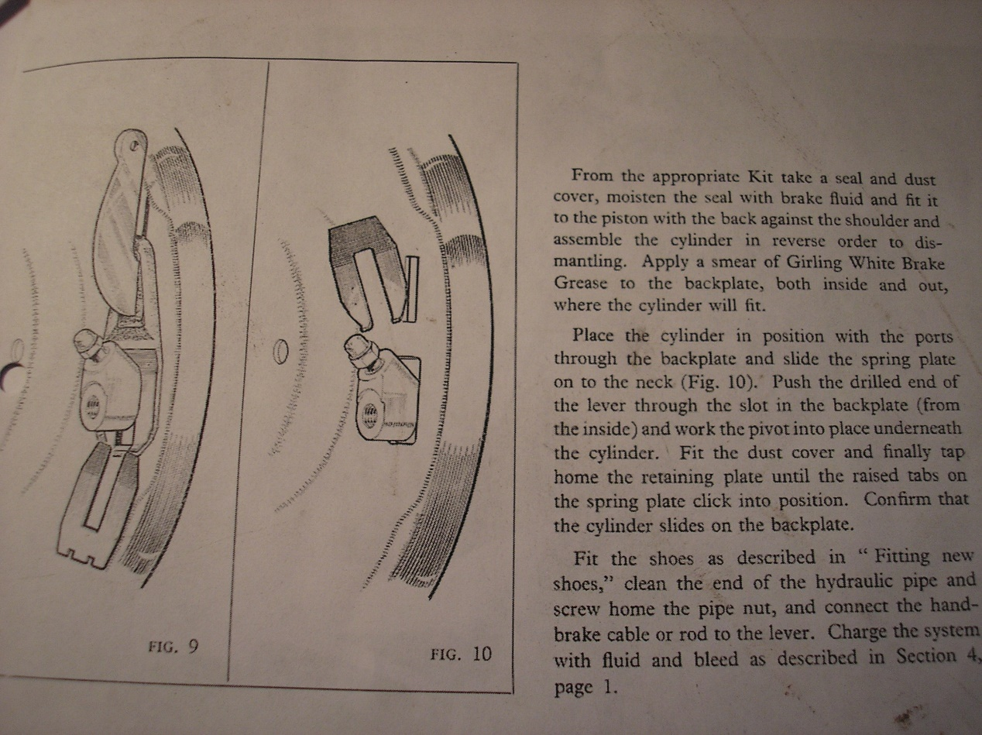

Simon Lachlan wrote:
I noticed that the wheel cylinder in one of my rear wheel drums is leaking slightly.
I have stripped out down to the removal of said cylinder. I am slightly hung up on the bit in the BMC book which refers to the “wheel cylinder locking plates”.
Disconnect the handbrake lever..remove brake shoes...disconnect pressure pipe..remove dust cover.all done.
Then “prise the retaining plate and spring plate apart and tap the retaining plate from beneath the neck of the wheel cylinder”.ho hum. The illustration shows 2 flat plates and the car showed a mess covered in crud and brake fluid. It seems that the plates cannot be flat? Maybe one is sprung and fits into the other?
Anyone care to enlarge before I go into battle with something which is probably child’s play the second time round?
Thanks,
Simon.

(1) The rubber boot(1) goes on the differential side of the back plate(5) with the handbrake lever(3) through the smaller hole and the wheel cylinder bleed screw(19) and line nut block(14) through the large hole. The flat surface of the boot goes against the brake back plate(5).
The curved clip(2) is then inserted into the groove in the wheel cylinder bleed screw and line nut block(14) from the hand brake lever side. This is a bit of a squeeze.
The flat clip(4), also in the groove in wheel cylinder bleed screw and line nut block, slides over the curved clip from the opposite side of the wheel cylinder bleed screw and line nut block in such a way that the tangs on the curved clip engage in the two small notches on the end of the flat clip.
When installed correctly the clips hold the wheel cylinder in place but allow it to slide in the slot in the back plate and the clips also retain the rubber boot in position.
It all sounds very complicated but once you have installed it you will see how logical it is.
Michael Salter
www.precisionsportscar.com
(2) Yes Simon,
One of the plates, the one with the little tabs on it, is curved. Usually these are relatively easy to remove just insert a small screwdriver in at the end of the wheel cylinder feed “pillar” to engage in the end of the slots of one of the plates and pry out. The plate should slide out of place.
Michael Salter
www.precisionsportscar.com

(3) One is flat. The one on top of that has two little “ears” that snap over the end of the bottom plate. You have to lift these taps up and then tap the top plate off.
John Sims, BN6
Aberdeen, NJ

(4) It’s not exactly child’s play. Especially when you can’t see things very well on the back side.
The two U shaped plates slide between the wheel cylinder flanges & the backing plate. One from each direction.
There is a small locking tab on the end of one of the plates that must be lifted a bit before the plates can be slipped apart & (driven) out.
Regards,
Dave Russell

(5) The 2 U shaped pieces are the key. The U shaped piece with the closed end on the top, this is the one against the backing plate with the legs pointing down, has a raised lip on the bottom of the legs. These raised lips lock into the other U shaped piece which faces upward. You will notice that the raised lips, on the back plate U, lock the outer clip in place and prevent it from sliding out of position. It really does not make a difference which clip is in which position, it is simply easier to remove the U with the 2 notches in it if it is on the outside. The piece with the 2 notches is shorter than the other piece and therefore should be on the outside making the removal and installation easier.
The trick is removing the U with the 2 notches first. Place a screwdriver at the top of legs of this U so that you can drive it off the other U with taps from a hammer. Don’t worry about trying to “unlock” the 2 pieces. The U with the 2 notches is shorter that the other U. Yes, you may have to hit it firmly to make it move and you will have to alternate from one leg to another. You must hit it hard enough for the notched U to be driven off of the other U. If yours are arranged the other way, it will just be harder to get the pieces to move. But, they will move. Once one is removed, the other will be easier to remove.
Yes, this, highlighted above, is the best bit of advice here:- disregard prising them apart. Put a blunt punch against top one and hammer it down and out. SDL 15/01/13
The brake cylinder will move while you are driving out the Us but it will bottom out so not to worry about it.
Once they are out, you will notice that the piece with the raised lips is slightly curved and that the other piece locks into place so that the 2 pieces will keep the brake cylinder firmly held against the backing plate.
Replace the pieces so that the U with the raised edges is against the backing plate with the closed end on top. That only leaves one way for the other piece to be installed. You will just find it easier this way. Yes, you will have to drive the outer piece back in place with a hammer and screw driver until it locks into place.
Take your time and you should have no problems. Clean everything completely and then, very lightly grease the outside of the backing plate where the 2 pieces slide. This insures that the brake cylinder will move to allow for shoe wear.
If I can be of additional help, let me know
Fred
63 BJ7

(6) Simon -Sod’s law. The pictures must be on my other computer - 30 miles away from here. But I’ll try to explain. The wheel cylinder sticks through the backplate and can slide a little bit. To allow for this sliding the cylinder is a wee bit shorter than the slot in the backplate. On the inside of the backplate (so the diff side) the wheel cylinder has two grooves, one at each side, and is locked in position by two U-shaped retaining plates. One is fitted from the lever side, the other from the other side - they overlap. To avoid them sliding apart, the plate closest to the backplate (‘retaining plate’) is flat, the other (‘spring plate’)has two ‘hooks’ which hook behind the edge of the retaining plate.
If you want to take the cylinder out you shall have to clean the inner side of the backplate so that you can see the hooks - once you see them, you’ll understand the construction and then it’s a matter of sliding the spring plate away, REMOVE THE LEVER, and then slide the retaining plate away. The cylinder drops in your hand, if you’ve done all correctly.
Sorry for this primitive description - if you could understand Dutch it would have been easier for me, but good luck!
Jack Aeckerlin, The Netherlands.
(See the pages that follows)

